Independent T-test with data

Type in the data, where each group gets their own column.

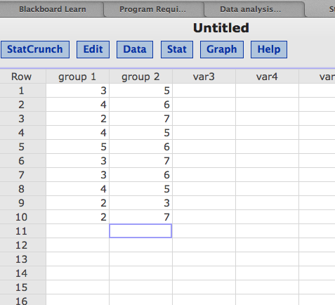

Click Stat > T-Statistics > Two Sample > With Data

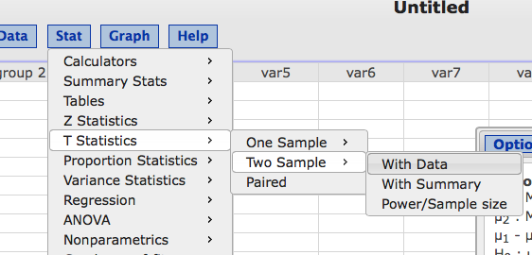

Put one column name in sample 1, one column name in sample 2.

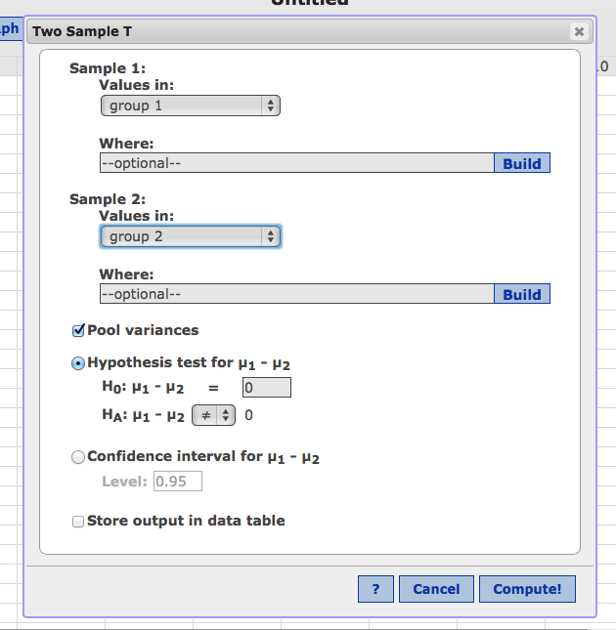

Click compute.

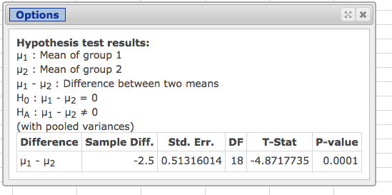

Std. Err. = Sdifference for step 2.

DF = df total for step 3

T-Stat = sample score on the comparison distribution for step 4

TO GET MEANS and VARIANCE for Step 2 and Effect Size

Stat > Summary Stat > Columns

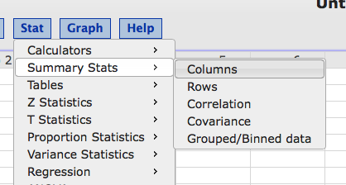

Click both variable names to move them over.

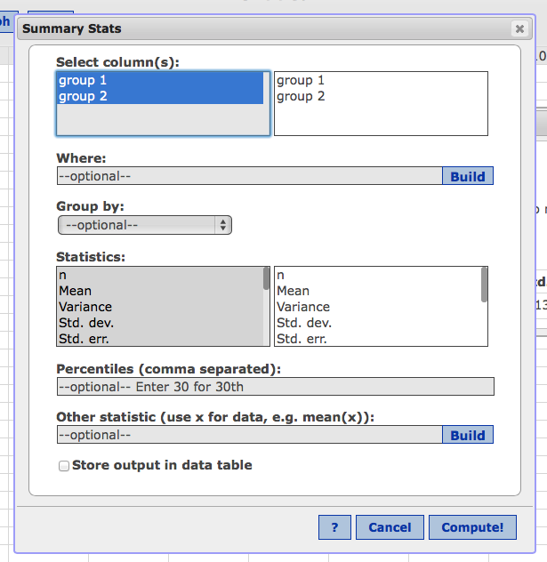

Click compute.

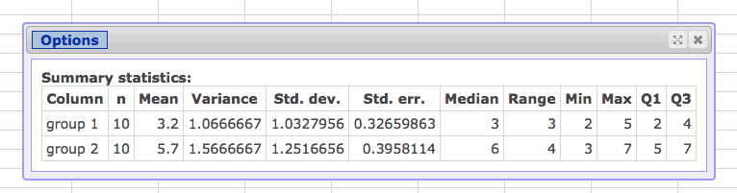

Mean = averages for step 2.

Variance = S2 for pooled variance for effect size.

Independent t with Summary

Click Stat > T Statistics > Two Sample > With Summary

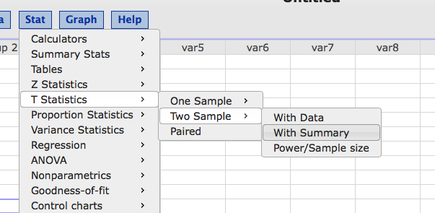

Type in the all numbers you have. Make sure to match SD (so if you get variance, take the square root first!), sample size is N.

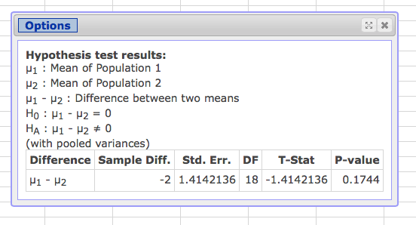

Std. Err. = Sdifference for step 2.

DF = df total for step 3.

T-Stat = sample score on the comparison distribution for step 4.